## FC Testing UPH Performance Analysis and Opportunities for NA (2024)

## 

**Observations**

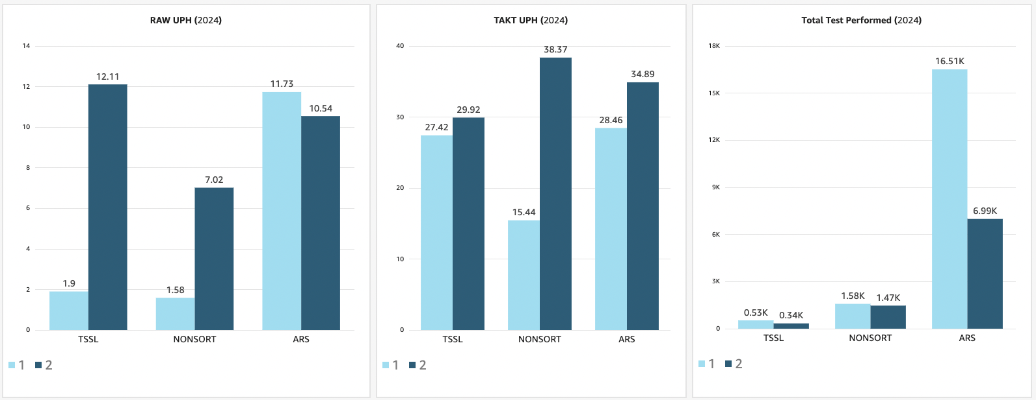

## Appendix

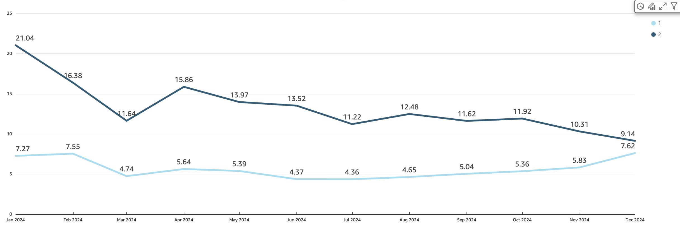**2024 Yearly trend for FC testing UPH across NA vs EU**

**2024 Monthly UPH Trend across FC_types NA vs EU**

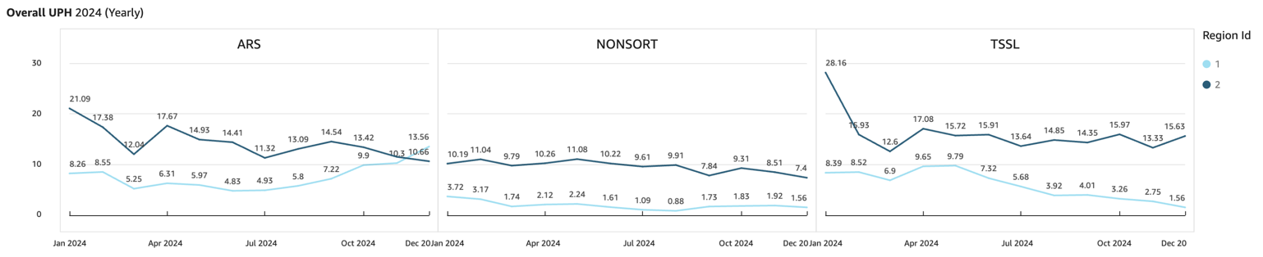

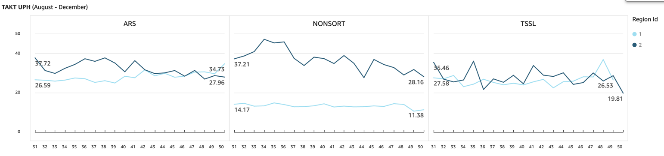

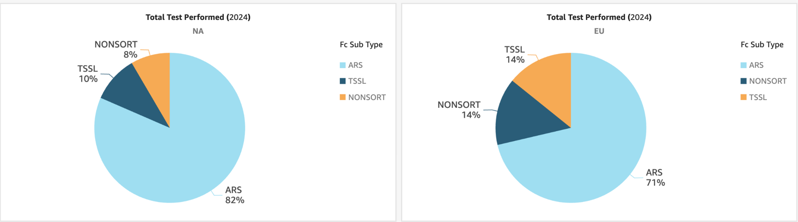**2024 Monthly Total Tests Performed FC_types NA vs EU**

